**Use Dynamic TEXT in adobe forms**

1. Go to Tcode SFP .Create an interface and then create a form(For details ,please refer the previous demos)

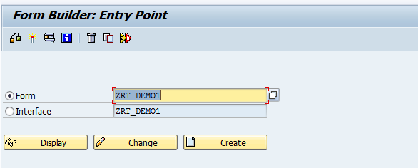

1. In the interface, create a importing parameter of type TSFTEXT

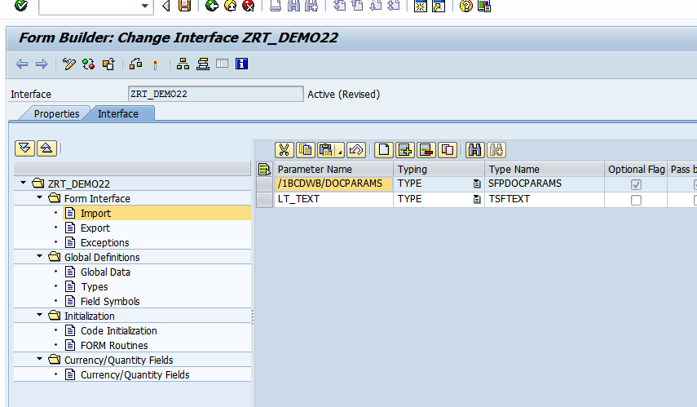

1. Open the Form in SFP. Drag and drop the importing parameter LT_TEXT from Interface to context.

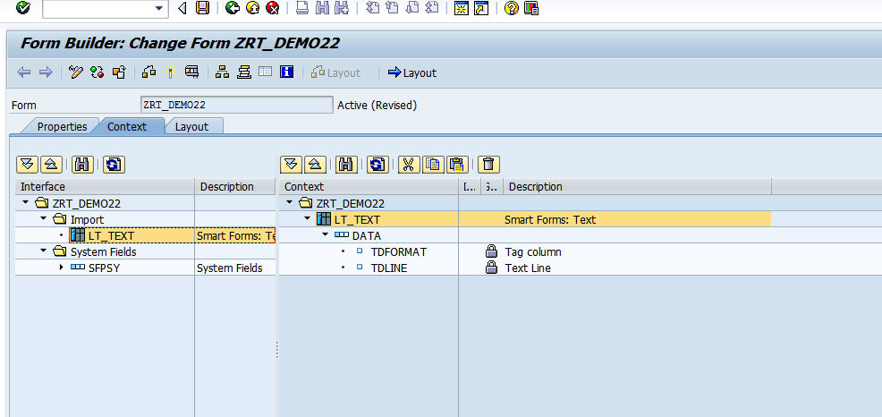

1. Right click on folder and create text as shown.

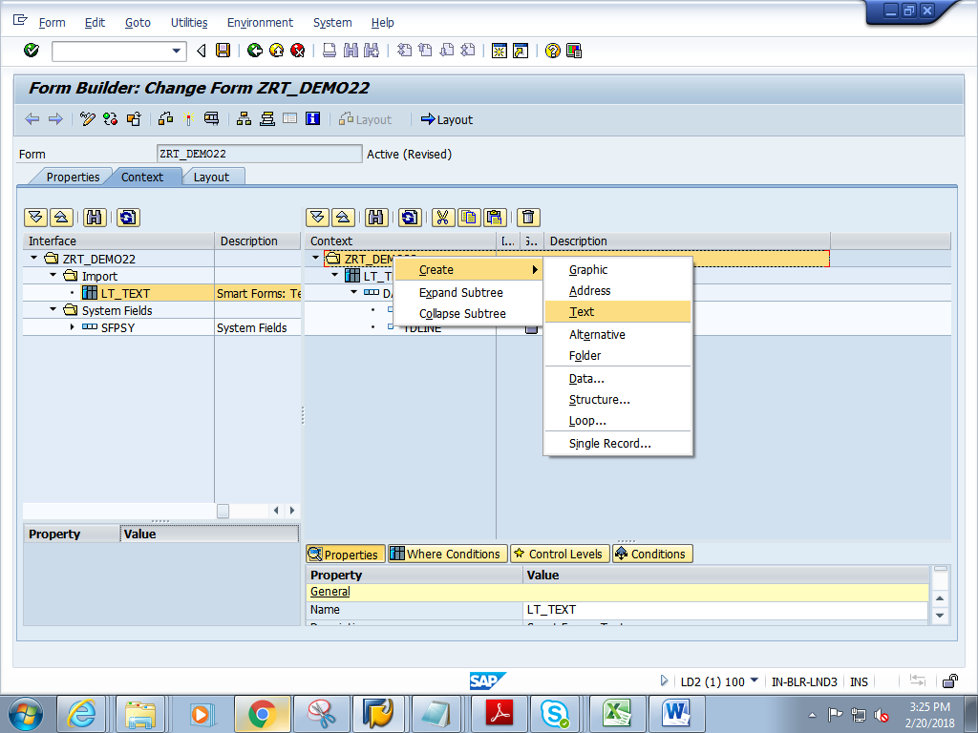

1. Rename the text to LV_TEXTDYNAMIC

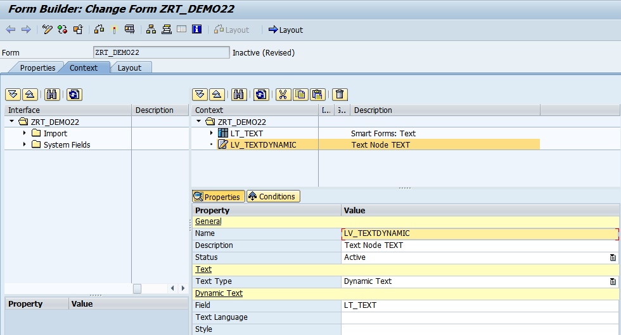

1. Change Text Type to  **DYNAMIC TEXT** and press enter

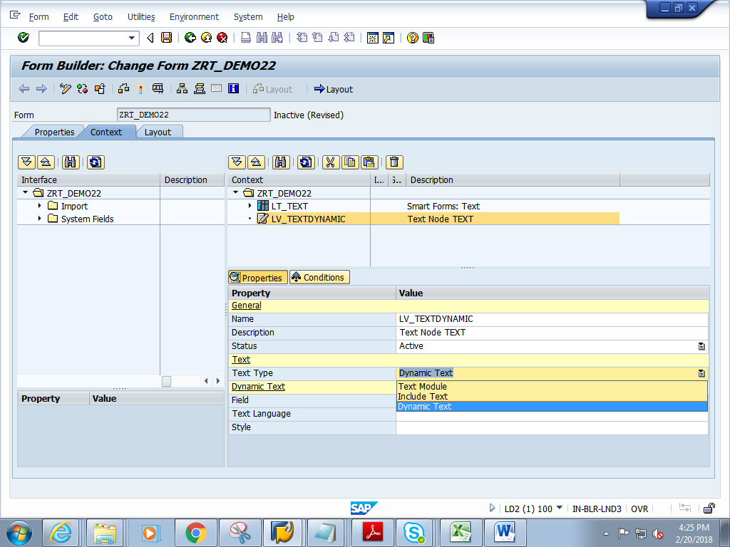

1. Give the Field as LT_TEXT

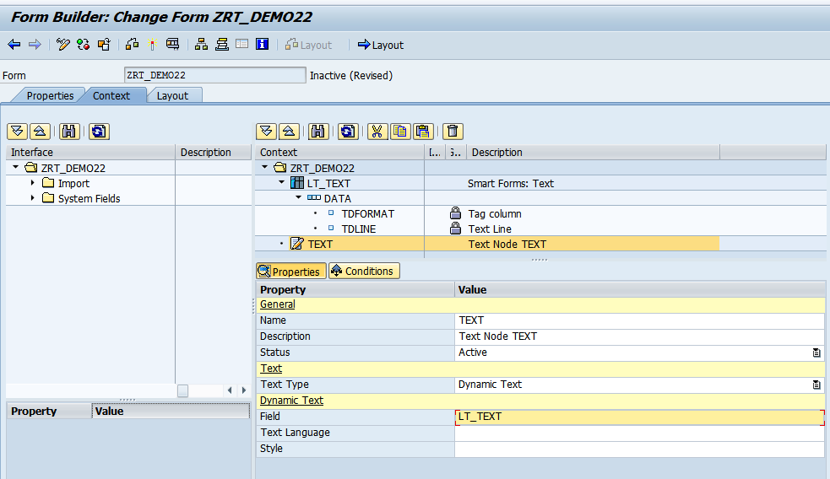

1. Save and click on Layout
2. In the Layout, drag and drop Text from Object Library to Design View. Resize the Text box and make it big enough.

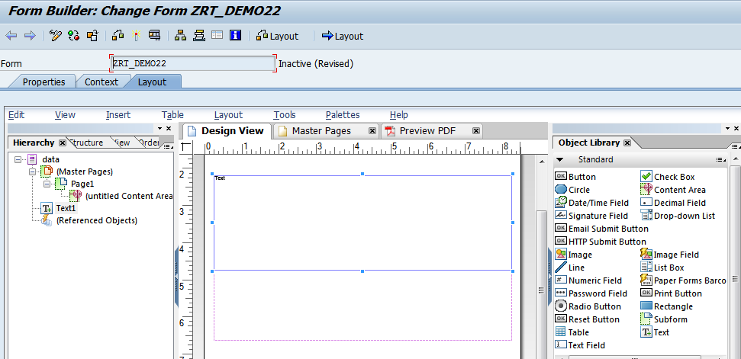

1. Right click on the word **Text** in the Text box and choose Floating field option

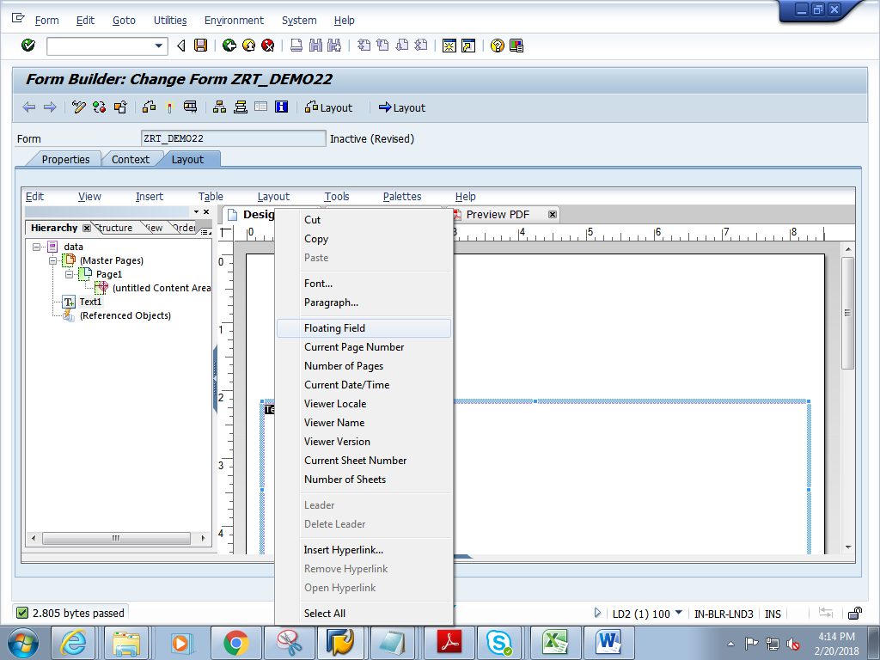

1. Select the text, then in the object window->Binding tab-> choose LV_TEXTDYNAMIC

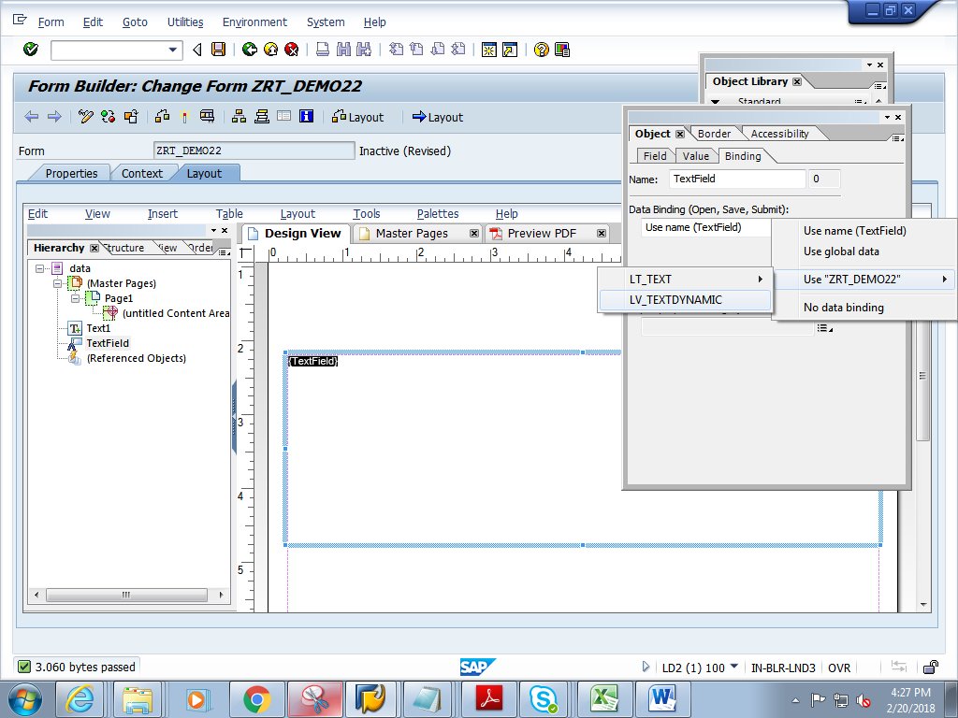

1. Save and close Layout.
2. Click on context. Save and activate the form
3. Execute the form .

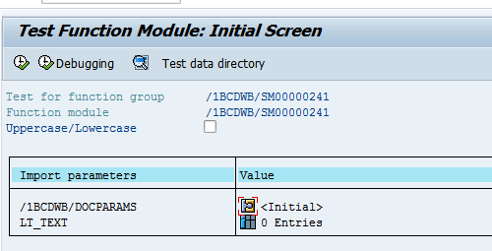

1. Create some internal table rows and go back.

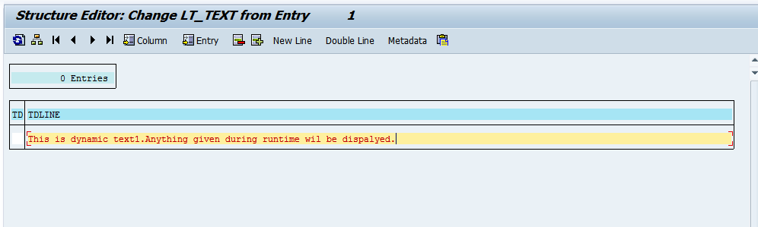

1. You can see 1 entry in the table.Execute.

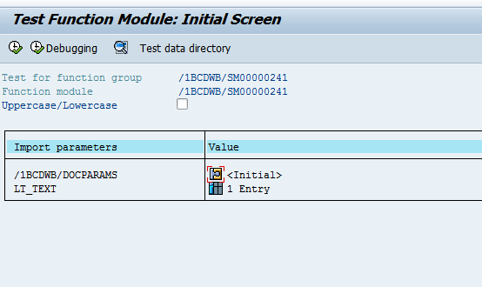

1. Click on Print preview

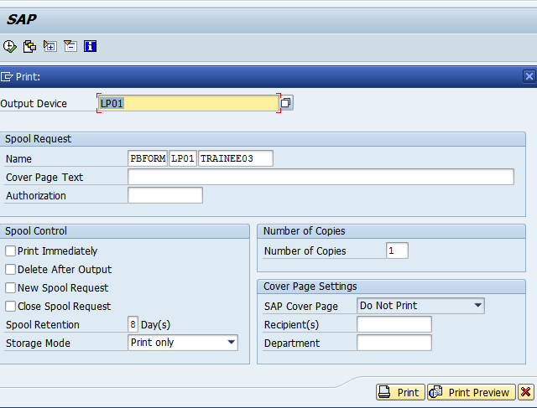

1. Expected output is as follows.

